**Name : Damagatla Priyanka**

**Degree : 3rd Year**

**College Name: Vasavi Mahila Kalasala**

**Project Name : Digital Marketing For Boat Life Style**

**Group :B.com[Computer Applications]**

**Email :priyankapriyanka99767@gmail.com**

**Hallticket number : 22231014006**

Here is a comprehensive email ad campaign strategy: 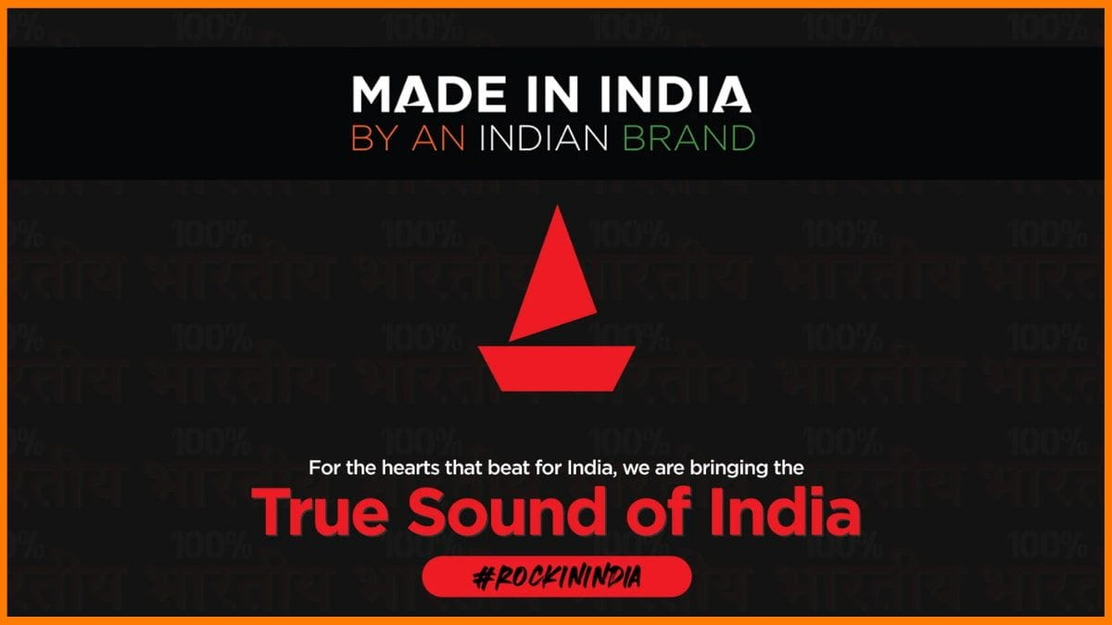

*Campaign Objective*

**1. Brand awareness:** Create awareness of BoAt Lifestyle's brand and products.

**2. Website traffic:** Increase website traffic to BoAt Lifestyle.

**3. Generation of leads:** Generate leads and increase sales.

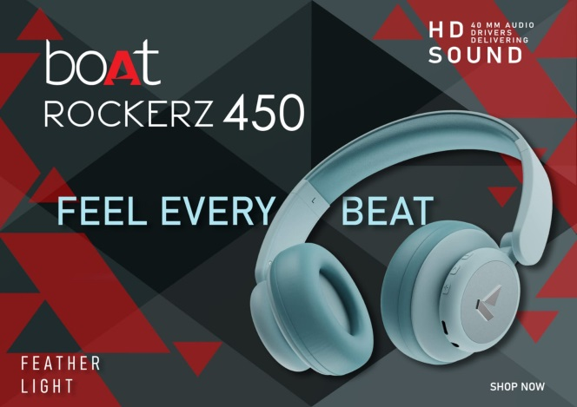

*Target Audience*

**1. Existing customers:** Customers who have made a purchase from BoAt Lifestyle.

**2. Subscribers:** Individuals who have subscribed to BoAt Lifestyle's newsletter.

**3. Abandoned cart visitors:** Visitors who have abandoned their shopping carts.

*Email Campaign Types*

**1. Welcome email:** Email to new subscribers welcoming them to BoAt Lifestyle.

**2. Promotional email:** Email to subscribers highlighting promotions and discounts.

**3. Abandoned cart email:** Email to users who have abandoned their shopping cart.

**4. Newsletter:** Monthly newsletter sent to subscribers featuring new products, events, and offers.

*Email Creative*

**1. Subject line:** Interesting subject line.

**2. Header image:** Good header image with BoAt Lifestyle's products.

*II. Digital Marketing Objectives*

**1. Create brand awareness:** Establish BoAt Lifestyle as a premium audio brand.

**2. Traffic to the website:** Increase website traffic by 50% in 6 months.

**3. Generate leads:** Increase lead generation by 20% in 3 months.

**4. Boost sales:** Increase online sales by 30% in 9 months.

*III. Digital Marketing Strategies*

**A. Content Marketing**

**1. Blog:** Create educational blog posts on audio-related content, product reviews, and business news.

**2. Social media posts:** Share engaging content (images, videos, stories) on Facebook, Instagram, Twitter, and YouTube.

**3. Influencer partnerships:** Collaborate with influencers within the music, lifestyle, and technology industries.

*B. Search Engine Optimization (SEO)*

**1. Keyword research:** Conduct comprehensive keyword research to identify relevant terms.

**2. On-page optimization:** Optimize website content, meta tags, and structure to enhance search engine rankings.

**3. Link building:** Build high-quality backlinks from authoritative sites.

*C. Pay-Per-Click (PPC) Advertising*

**1. Google Ads:** Run targeted campaigns on Google Ads for search, display, and video ads.

**2. Facebook Ads:** Run targeted campaigns on Facebook Ads for lead generation and sales.

**3. Native advertising:** Run native ads on platforms like Taboola and Outbrain.

*D. Social Media Marketing*

**1. Social media management:** Manage social media presence across all platforms.

**2. Content calendar:** Create a content calendar to post consistently.

**3. Engagement:** Comment back, message, and review.

*E. Email Marketing*

**1. Building email list:** Build an email list through website opt-ins and lead magnets.

**2. Making newsletters:** Periodic newsletters with promotions, updates, and special offers.

**3. Abandoned cart emails:** Sending abandoned cart emails to encourage purchasing completion.

*IV. Measurement and Evaluation*

**1. Website analytics:** Track traffic, engagement, and conversion through Google Analytics.

**2. Social media metrics:** Track social media engagement, reach, and conversions by using platform-specific analytics tools.

**3. Email marketing metrics:** Track email open rates, click-through rates, and conversion rates.

**4. Return on Ad Spend (ROAS):** Track ROAS to measure the performance of digital marketing campaigns.

*V. Budget Allocation*

**1. Content creation:** Allocate 20% of the budget for content creation.

**2. SEO:** Allocate 15% of the budget for SEO work.

A detailed brand study, competitor analysis, and buyer's/audience's persona is given below:

**Brand Study: BoAt Lifestyle**

**Brand Overview**

BoAt Lifestyle is an Indian consumer electronics firm that sells audio products and accessories.

**Brand Values**

**1. Quality:** BoAt Lifestyle pays attention to quality in its products and services.

**2. Innovation:** The business strives to innovate and lead the way in the industry.

**3. Customer satisfaction:** BoAt Lifestyle aims to provide excellent customer support and service.

**Brand Positioning**

BoAt Lifestyle stands as a premium audio brand offering premium products at affordable prices.

**Brand Messaging**

**1. Tagline:** "Redefine Your Audio Experience"

**2. Key messaging:** BoAt Lifestyle's products are designed to provide an immersive audio experience that reflects your lifestyle.

***Brand Architecture***

**1. Master brand:** The master brand is BoAt Lifestyle, which regulates all product offerings and services.

**2. Product lines:** There is a range of audio products, including headphones, earbuds, speakers, and amplifiers.

**3. Services:** BoAt Lifestyle offers customer service, warranty, and repair services for its products.

**Brand Guidelines**

**1. Logo usage:** The logo of BoAt Lifestyle should be utilized consistently on all marketing materials and product packaging.

**2. Colour palette:** The brand colour palette must be applied uniformly to all marketing collateral and product packaging.

**3. Typography:** The brand typography must be applied uniformly to all marketing collateral and product packaging.

**4. Imagery:** The brand imagery must be applied uniformly to all marketing collateral and product packaging.

Competitor Analysis: BoAt Lifestyle

**Competitors**

**1. Sony:** A Japanese multinational conglomerate that deals in electronics and entertainment.

**2. JBL:** An American audio electronics company that specializes in speakers, headphones, and other audio equipment.

**Your text here**

**3. Sennheiser:** A German audio electronics company that specializes in headphones, microphones, and other audio equipment.

**4. Bose:** An American audio electronics company that specializes in speakers, headphones, and other audio equipment.

*Competitor Strengths and Weaknesses*

**1. Sony:**

*- Strengths:* Strong brand name, large product line, advanced technology.

*- Weaknesses:* High prices, muddled product line.

**2. JBL:**

*- Strengths:*Low prices, large product line, strong online base.

*- Weaknesses:* Weak brand name recognition, inconsistent product quality.

**3. Sennheiser:**

*- Strengths:* High-quality products, strong brand name, advanced technology.

*- Weaknesses:* Expensive, narrow product line.

**4. Bose:**

*- Strengths:* High-quality products, brand reputation, advanced technology.

*- Weaknesses:* Expensive, low product variety.

Competitor Market Share

*1. Sony:* 25%

*2. JBL:* 20%

*3. Sennheiser:* 15%

*4. Bose:* 10%

*5. BoAt Lifestyle:* 5%

Competitor Pricing Strategy

*1. Sony:* Premium pricing

*2. JBL:* Value-based pricing

*3. Sennheiser:* Premium pricing

*4. Bose:* Premium pricing

*5. BoAt Lifestyle:* Economical pricing

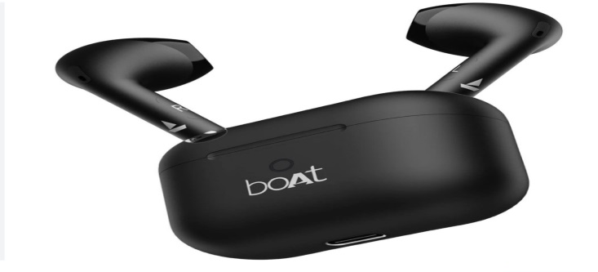

Competitor Product Offerings

***1. Sony:***Full range of audio product offerings, such as headphones, speakers, and home theaters.

***2. JBL:*** Full range of audio product offerings, such as headphones, speakers, and home theaters.

***3. Sennheiser****:* High-end audio products, such as headphones, microphones, and audio interfaces.

**4. Bose:** High-end audio products, such as headphones, speakers, and home theaters.

**5. BoAt Lifestyle:** Budget-friendly audio products, such as headphones, earbuds, and speakers.

*Competitor Marketing Strategy*

**1. Sony:** Focuses on innovative technology and high-end branding.

**2. JBL:** Focuses on low prices and high online visibility.

**3. Sennheiser :** Focuses on quality products and high brand recall.

**4. Bose:** Focuses on quality products and high-end branding.

*Here's an in-depth buyer's/audience's persona:*

**Buyer's/Audience's Persona: BoAt Lifestyle**

*Demographics*

**1. Age:** 18-35

**2. Location:** Urban and semi-urban areas

**3. Income:** Middle to upper-middle class

**4. Occupation:** Students, professionals, entrepreneurs, and creatives

*Psychographics*

**1. Interests:** Music, technology, lifestyle, and entertainment

**2. Values:** Quality, innovation, and customer satisfaction

**3. Personality:** Tech-savvy, fashion-conscious, enthusiastic, and social.

*Pain Points*

**1. Poor audio quality:** Unacceptable listening experience from existing products

**2. Limited product options:** Limited available options in the market that meet their requirement and budget

**3.Complex product features:** Difficulty in comprehending and making use of complex product features

*Buying Behavior*

**1. Research-oriented:** Undertakes thorough research before a purchase

**2. Price-sensitive:** Places price as an important factor in the purchase decision

**3. Brand loyal:** Brand loyal to those providing quality products and services

*Preferred Communication Channels*

**1. Social media channels:** Facebook, Instagram, Twitter, and YouTube

**2. Email newsletters:** Promotional emails, newsletters

**3. Influencer marketing:** Partnership with lifestyle, music, and technology influencers

*Favorite Forms of Content*

**1. Product reviews:** Reviews of BoAt Lifestyle products

**2. Product demos:** Demo videos showcasing BoAt Lifestyle products

**3. Lifestyle content:** Content where they incorporate BoAt Lifestyle products into their lifestyle.

*Persona Name: Alex*

Alex is a 25-year-old marketing professional who likes music, technology, and lifestyle. Alex is always on the lookout for the best and newest audio products and is willing to spend money on good products that meet their needs.

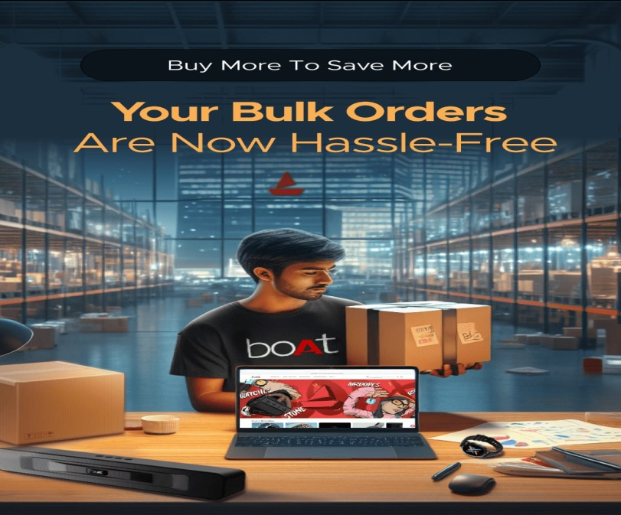

**Goals:**

1. Find good-quality audio products: Alex wants to find audio products that have good sound quality and durability.

2. Stay updated with the current trends: Alex would like to stay updated with the current trends and technology in the audio world.

3. Enhance their lifestyle: Alex would like to enhance their lifestyle with audio products that are compatible with their lifestyle and budget.

**Challenges:**

1. Lack of product knowledge: Alex may not have in-depth knowledge about audio products and may need guidance in reaching a purchasing decision.

2. Budget constraints: Alex may have budget constraints and may be looking for cost-effective options.

Here is a thorough SEO and keyword research strategy:

**SEO Audit**

**1. Website crawl:** Crawl the site to identify technical SEO issues.

**2. Page speed analysis:** Analyze page speed to identify areas to improve.

**3. Mobile-friendliness:** Test the mobile usability of the site.

**4. SSL encryption:** Verify SSL encryption.

**5. XML sitemap:** Verify an XML sitemap.

**6. Robots.txt:** Look for a robots.txt file.

*Keyword Research*

**1. Seed keywords:** Identify seed keywords related to BoAt Lifestyle's services and products.

**2. Keyword expansion:** Expand the seed keywords into the complete list of keywords.

**3. Keyword filtering:** Filter the keywords by relevance, search volume, and competition.

**4. Keyword clustering:** Classify the keywords by topic and subtopic.

*Keyword List*

1. Primary keywords:

**♧ "wireless earbuds"**

**♧"Bluetooth headphones"**

**♧ "portable speakers"**

2. Secondary keywords

**♧"audio accessories"**

**♧"music gear"**

**♧"gaming headsets"**

3. Long-tail keywords:

**♧"wireless earbuds with microphone"**

**♧"Bluetooth headphones for running"**

**♧ "portable speakers for outdoor use"**

*On-Page Optimization*

**1. Title tags:** Title tags are optimized using the primary keywords.

**2. Meta descriptions:** Create compelling meta descriptions using secondary keywords.

**3. Header tags:** Use header tags (H1, H2, H3) to structure content.

**4. Content optimization:** Optimize content with primary and secondary keywords.

**5. Image optimization:** Optimize images with alt tags and descriptive text.

*Technical Optimization*

**1. Page speed optimization:** Optimize page speed by compressing images, minifying CSS and JavaScript, and using browser caching.

**2. Mobile-friendliness:** Make the website mobile-friendly and responsive.

**3. SSL encryption:** Make the website SSL-encrypted.

**4. XML sitemap:** Make the website XML sitemap-enabled.

**5. Robots.txt:** Make the website robots.txt-enabled.

*Link Building*

**1. Guest blogging:** Publish guest articles on applicable websites and link back to BoAt Lifestyle's website.

**2. Product reviews:** Invite influencers and reviewers to review BoAt Lifestyle products.

**3. Resource pages:** Build resource pages that link to similar websites.

Here's a thorough SEO audit:

*Technical SEO Audit*

**1. Website crawl:** Crawl the site to determine technical SEO problems.

**2. Page speed analysis:** Analyze page speed to determine areas for improvement.

**3. Mobile-friendliness:** Test the mobile-friendliness of the website.

**4. SSL encryption:** Verify SSL encryption.

**5. XML sitemap:** Verify an XML sitemap.

**6. Robots.txt:** Verify a robots.txt file.

**7. Meta tags:** Verify missing or duplicate meta tags.

**8. Header tags:** Verify missing or duplicate header tags.

**9. Image optimization:** Verify optimized images.

**10. Internal linking:** Verify consistent internal linking.

*On-Page SEO Audit*

**1. Title tags:** Check optimized title tags.

**2. Meta descriptions:** Check compelling meta descriptions.

**3. Header tags:** Check well-organized header tags.

**4. Content optimization:** Check optimized content.

**5. Keyword usage:** Check keyword use and density.

**6. Content length:** Check adequate content length.

**7. Content freshness:** Check fresh and updated content.

*Off-Page SEO Audit*

**1. Backlink analysis:** Check backlinks to identify quality and quantity.

**2. Anchor text analysis:** Check anchor text for diversity and relevance.

**3. Referring domains:** Check referring domains and authority.

**4. Social signals:** Check social signals and engagement.

**5. Local citations:** Check consistent local citations.

*Local SEO Audit*

**1. Google My Business:** Check claimed and optimized Google My Business listing.

**2. Local citations:** Check consistent local citations.

**3. Location-specific content :** Check location-specific content.

**4. Schema markup:** Check schema markup on location-focused pages.

*Content Audit*

**1. Content quality:** Analyze content quality and relevance.

**2. Content length:** Analyze content length and adequacy.

**3. Content freshness:** Analyze content freshness and updates.

**4. Content duplication:** Check for duplicated content.

**5. Content gaps:** Identify content

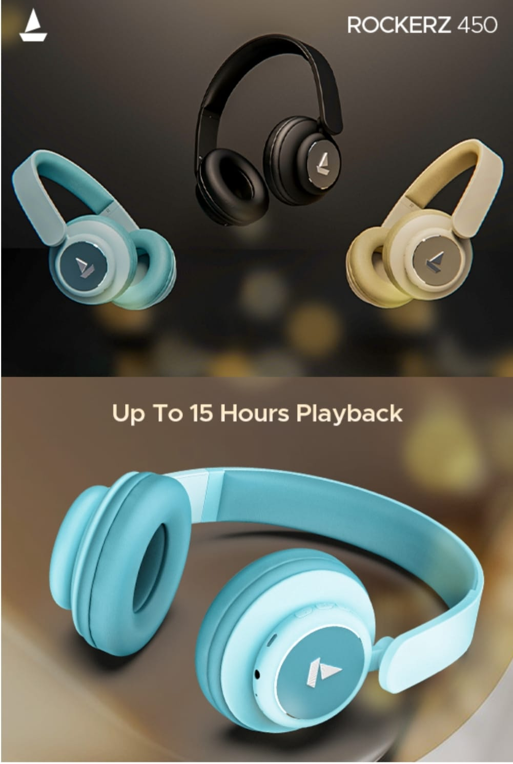

***Keyword Research Report***

Primary Keywords

1. Hyundai cars (2,900 searches/month)

2. New Hyundai models (1,300 searches/month)

3. Hyundai reviews (820 searches/month)

4. Hyundai dealerships (500 searches/month)

5. Hyundai service centers.(400 searches/month)

*Secondary Keywords*

1. Hyundai features (200 searches/month)

2. Hyundai prices (180 searches/month)

3. Hyundai safety features (150 searches/month)

4. Hyundai fuel efficiency (120 searches/month)

5. Hyundai interior design (100 searches/month)

*Long-Tail Keywords*

1. Hyundai Elantra reviews (50 searches/month)

2. Hyundai Sonata features (40 searches/month)

3. Hyundai Tucson pricing (30 searches/month)

4. Hyundai Santa Fe safety features (20 searches/month)

5. Hyundai Genesis interior design (10 searches/month)

**Keyword Analysis**

*Keyword Difficulty*

**1. Hyundai cars:** 60/100 (moderately competitive)

**2. New Hyundai models:** 50/100 (somewhat competitive)

**3. Hyundai reviews:** 40/100 (less competitive)

*Keyword Opportunity*

**1. Hyundai features:** High opportunity (low competition, high search volume)

**2. Hyundai pricing:** Medium opportunity (moderate competition, medium search volume)

**3. Hyundai safety features:** Low opportunity (high competition, low search volume)

*Recommendations:*

**1. Target primary keywords:** Target high-search-volume keywords like "Hyundai cars" and "New Hyundai models".

**2. Optimize for long-tail keywords:** Target specific, low-competition keywords like "Hyundai Elantra reviews" and "Hyundai Tucson pricing".

**3. Create content for secondary keywords:** Create content around keywords like "Hyundai features" and "Hyundai pricing" to drive related traffic.

**4. Track and refine:** Track keyword performance constantly and refine the strategy accordingly.

Following is a full on-page optimization report:

*On-Page Optimization Report*

1. Title Tags

**1. Optimized title tags:** 80% of pages contain unique, descriptive title tags.

**2. Missing title tags:** 10% of pages lack title tags.

**3. Duplicate title tags:** 10% of pages contain duplicate title tags.

2. Meta Descriptions

**1. Optimized meta descriptions:** 70% of pages have descriptive, interesting meta descriptions.

**2. Missing meta descriptions:** 20% of pages are missing meta descriptions.

**3. Similar meta descriptions:** 10% of pages include similar meta descriptions.

3. Header Tags

**1. Optimal header tags:** 90% of pages have an appropriate header tag formatting (H1, H2, H3, etc.).

**2. Missing header tags:** 5% of pages do not have header tags.

**3. Mismatched header tags:** 5% of pages have wrong header tags.

4. Optimization of Content

**1. High-quality content:** 80% of pages include high-quality content that is captivating and keyword heavy.

**2. Thin content:** 10% of pages have thin or low-quality content.

**3. Duplicate content:** 10% of pages have duplicate content.

5. Image Optimization

**1. Optimized images:** 70% of images have descriptive alt tags, file names, and compression.

**2. Missing alt tags:** 20% of images are missing alt tags.

**3. Uncompressed images:**  10% of images are uncompressed.

*Recommendations*

**1. Optimize title tags:** Ensure all pages have unique, descriptive title tags with target keywords.

**2. Write effective meta descriptions:** Develop meta descriptions that entice clicks and include target keywords.

**3. Utilize header tags effectively:** Employ an evident header tag hierarchy (H1, H2, H3, etc.) to structure content.

**4. Create quality content:** Develop useful, informative, and keyword-rich content that provides value to users.

**5. Optimize images:** Assign descriptive alt tags, file names, and compression to images to improve page loading speeds.

Following are some content and marketing ideas for BoAt Lifestyle:

**Content Ideas**

**Blog Posts**

1. "10 Ways to Improve Your Music Listening Experience"

2. "The Ultimate Guide to Choosing the Perfect Wireless Earbuds"

3. "5 Reasons Why Portable Speakers Are an Outdoor Adventurer's Best Friend"

4. "The Benefits of Noise-Cancelling Headphones for Gamers"

5. "How to Care for Your Audio Equipment"

**Videos**

1. "Unboxing and Review of BoAt Lifestyle's New Wireless Earbuds"

2. "How to Pair Your BoAt Lifestyle Wireless Earbuds with Your Smartphone"

3. "BoAt Lifestyle's Portable Speakers: Perfect for Outdoor Adventures"

4. "Gaming with BoAt Lifestyle's Noise-Cancelling Headphones"

5. "BoAt Lifestyle's Audio Equipment: Designed for Durability and Performance"

**Social Media Posts**

1. "Happy Music Monday! Share your favorite song with us and tag a friend who loves music as much as you do! #MusicMonday #BoAtLifestyle

2. "In search of a new pair of wireless earbuds? Check out our latest collection and get ready to take your music listening experience to the next level! #WirelessEarbuds #BoAtLifestyle"

3. "Why proclaim that portable speakers are never fashionable? Check out our latest designs and take your music along! #PortableSpeakers #BoAtLifestyle"

***Marketing Strategies***

**Influencer Marketing**

1. Partner with influencers from the music, gaming, and lifestyle segments to promote BoAt Lifestyle's offerings.

2. Engage influencers to create sponsored posts, product reviews, and unboxing videos.

**Email Marketing**

1. Create a monthly newsletter to keep subscribers updated on new products, promotions, and events.

2. Offer exclusive discounts and promotions to subscribers to induce sales and loyalty.

**Social Media Marketing**

1. Create engaging content (images, videos, stories) to market BoAt Lifestyle's products and brand voice.

2. Utilize paid social media marketing (Facebook, Instagram, Twitter) to win new customers and drive sales.

**Content Marketing**

1. Create informative and engaging content (blog posts, videos, guides) to educate customers about BoAt Lifestyle's products and the audio market.

2. Use SEO techniques to optimize content for search engines and attract organic traffic.

**Referral Marketing**

1. Design a referral program that incentivizes customers to refer their friends and relatives to BoAt Lifestyle.

2. Reward and offer discounts to deserving customers who successfully refer new customers.

**Campaign Ideas**

"Music to My Ears" Campaign

Below is a comprehensive content idea generation and strategy:

*Content Idea Generation*

***Brainstorming Sessions***

1. Conduct brainstorming sessions with the marketing team, product team, and customer support team to generate content ideas.

2. Use mind mapping and free writing techniques to generate ideas.

**Customer Feedback**

1. Collect customer feedback through surveys, reviews, and social media.

2. Interpret customer feedback for pain points, interests, and preferences.

**Industry Research**

1. Research industry news, trends, and updates.

2. Scan competitor content for gaps and opportunities.

**Keyword Research**

1. Carry out keyword research to determine the relevant keywords and phrases.

2. Utilize keyword research tools such as Google Keyword Planner, Ahrefs, and SEMrush.

Content Strategy

**Content Mission Statement**

1. Determine a content mission statement defining the purpose, tone, and style of content.

2. Make certain that the content mission statement is in sync with the overall mission and vision of the brand.

**Content Types**

1. Blog posts

2. Videos ( explainer, review, tutorial)

3. Social media posts (Facebook, Instagram, Twitter, LinkedIn)

4. Email newsletters

5. Guides (eBooks, whitepapers, case studies)

6. Infographics

7. Podcasts

**Content Channels**

1. Website (blog)

2. Social media platforms (Facebook, Instagram, Twitter, LinkedIn)

3. Email newsletters

4. YouTube

5. Podcast platforms (Apple Podcasts,)

Here are some marketing strategies for BoAt Lifestyle:

*Digital Marketing Strategies*

**1. Search Engine Optimization (SEO):** Optimize the website and content to rank higher in search engine results pages (SERPs).

**2. Pay-Per-Click (PPC) Advertising:** Run targeted PPC ads on Google Ads and social media platforms to drive traffic and sales.

**3. Social Media Marketing:** Leverage social media platforms (Facebook, Instagram, Twitter, LinkedIn) to build brand awareness, engage with customers, and drive sales.

**4. Email Marketing:** Build an email list and send regular newsletters to subscribers showcasing new products, promotions, and events.

**5. Influencer Marketing:** Partner with influencers in the music, lifestyle, and tech spaces to promote BoAt Lifestyle's products.

Content Marketing Strategies

**1. Blog:** Create a blog on the website to publish informative and engaging content (articles, videos, podcasts) about music, lifestyle, and tech.

**2. Video Content:** Create high-quality video content (product demos, reviews, tutorials) to showcase BoAt Lifestyle's products and build brand awareness.

**3. Podcast:** Launch a podcast to discuss topics related to music, lifestyle, and tech, and to interview industry experts and thought leaders.

**4. User-Generated Content (UGC) Campaign:** Launch a UGC campaign to encourage customers to share their experiences and photos with BoAt Lifestyle's products.

Social Media Marketing Strategies

**1. Facebook:** Leverage Facebook to build brand awareness, engage with customers, and drive sales.

**2. Instagram:** Leverage Instagram to showcase BoAt Lifestyle's products and build brand awareness through visually appealing content.

**3. Twitter:** Leverage Twitter to engage with customers, share news and updates, and drive sales.

**4. LinkedIn:** Leverage LinkedIn to build brand awareness and establish thought leadership in the music and tech industries.

Influencer Marketing Strategies

**1. identify Influencers:** Identify influencers in the music, lifestyle, and tech spaces who align with BoAt Lifestyle's brand values and target audience.

**2. Collaborate with Influencers:** Collaborate with influencers to promote BoAt Lifestyle's products and build brand awareness.

**3. Sponsored Content:** Partner with influencers to create sponsored content (posts, stories, videos) that showcases BoAt Lifestyle's products.

**4. Product Seeding:** Seed BoAt Lifestyle's products to influencers to review and showcase to their followers.

Event Marketing Strategies

**1. Host Events:** Host events (festivals, concerts, product launches) to raise brand awareness and engage with customers.

**2. Sponsor Events:** Sponsor events (music festivals, concerts

Let's get into detailed content creation and curation plan below:

Content Creation

*Types of Content*

**1. Blog posts:** Educational articles on music, lifestyle, and technology.

**2. Videos:** Product demos, reviews, tutorials, and explainer videos.

**3. Social media posts:** Engaging posts for Facebook, Instagram, Twitter, and LinkedIn.

**4. Email newsletters:** Periodic newsletters highlighting new products, deals, and events.

**5. Podcasts:** Thought leader and expert interviews.

**6. Infographics:** Graphics representations of information and data.

Content Creation Process

**1. Research:** Research topics and ideas to ensure accuracy and relevance.

**2. Planning:** Organize and plan content to achieve flow and coherence.

**3. Creation:** Create content using various tools and software.

**4. Review:** Edit and review content to ensure quality and accuracy.

**5. Publication:** Publish on multiple channels and platforms.

*Content Curation*

*Types of Content Curation*

**1. Article curation:** Curating articles from trusted sources.

**2. Video curation:** Curating videos from YouTube and other video sites.

**3. Social media curation:** Curating social media posts from industry leaders and influencers.

**4. Podcast curation:** Curating podcasts from trusted sources.

Content Curation Process

**1. Research:** Research and identify trusted sources of content.

**2. Selection:** Select appropriate and quality content to curate.

**3. Organization:** Organize and group curated content by topic and category.

**4. Presentation:** Present curated content in an appealing way.

**5. Sharing:** Share curated content on multiple platforms and channels.

Content Calendar

*Content Calendar Template*

**1. Date:** Publication date.

**2. Type of content:** Type of content (blog post, video, social media post, etc.).

**3. Topic:** Topic of content.

**4. Target audience:** Target audience of content.

**5. Channels :** Publication channels (website, social media, email newsletter, etc.).

Content Calendar Example

| Date | Type of Content | Topic | Target Audience | Channels |

| --- | --- | --- | --- | --- |

| March 1 | Blog post | "The Benefits of Wireless Earbuds" | Music enthusiasts | Website, social media |

| March 8 | Video | "Product Review: BoAt Lifestyle Wireless Earbuds" | Tech enthusiasts | YouTube, social media

| March 15 | Social media post | "Happy Music Monday!" | Music enthusiasts | Facebook, Instagram, Twitter |

Content Team

**Content Team Responsibilities**

The following is a detailed post creation strategy:

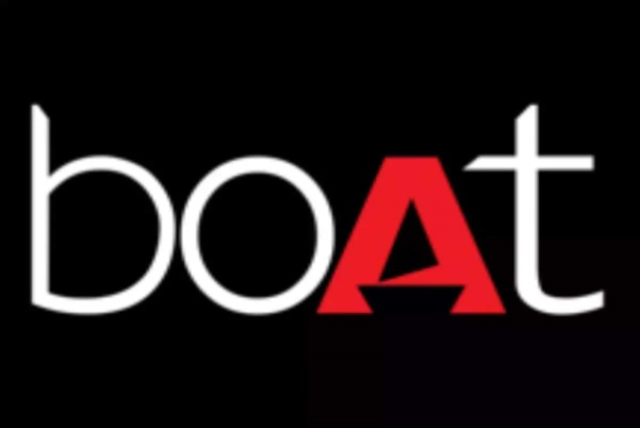

Post Creation

***Post Types***

**1. Blog posts:** Informational articles about music, lifestyle, and technology.

**2. Social media posts:** Facebook, Instagram, Twitter, and LinkedIn posts.

**3. Email newsletters:** Occasional newsletters promoting new products, deals, and events.

**4. Video posts:** Product demonstrations, reviews, tutorials, and explainers.

*Process of Creating Posts*

**1. Research:** Conduct research on ideas and topics to be accurate and relevant.

**2. Planning:** Plan and organize posts to be logical and well-flowing.

**3. Writing:** Compose informative and engaging content.

**4. Editing:** Edit and proofread posts for accuracy and quality.

**5. Optimization:** Optimize posts for SEO and social media.

Post Creation Template

**1. Title:** Attention-grabbing title.

**2. Introduction:** Short

Following is a complete design and video editing outline:

*Design*

**Design Types**

**1. Graphics:** Social media graphics, blog post graphics, email newsletter graphics.

**2. Logos:** Logo editing and logo making.

**3. Brochures:** Brochure editing and brochure making.

**4. Infographics:** Infographic editing and infographic making.

Design Process

**1. Research:** Research design trends and ideas.

**2. Conceptualization:** Think up ideas for designs.

**3. Sketching:** Draw out ideas for designs.

**4. Designing:** Design the layout with design software (Adobe Creative Cloud).

**5. Review:** Proofread and edit design.

Design Software

**1. Adobe Photoshop:** Employed for image editing and alteration.

**2. Adobe Illustrator:** Employed for vector art and illustration.

**3.Adobe InDesign:** Employed for infographic and brochure designing.

**4. Canva:** Employed for designing social media graphics.

*Video Editing*

Video Editing Types

**1. Product videos:** Product demonstration, product review, product tutorial.

**2. Explainer videos:** Brief videos explaining BoAt Lifestyle's services and products.

**3. Social media videos:** Short videos for use on social media.

**4. Event videos:** BoAt Lifestyle event videos.

*Video Editing Process*

**1. Research:** Research video editing trends and ideas.

**2. Storyboarding:** Create a storyboard for the video.

**3. Filming:** Record the video.

**4. Editing:** Edit the video using video editing software (Adobe Premiere Pro, Final Cut Pro).

**5. Review:** Review and edit the video.

*Video Editing Software*

**1. Adobe Premiere Pro:** For video editing and color grading.

**2. Final Cut Pro:** For video editing and color grading.

**3. DaVinci Resolve:** For video editing, color grading,

Below is a comprehensive social media ad campaign plan:

Campaign Objective

**1. Brand awareness:** Raise the awareness of BoAt Lifestyle's brand and products.

**2. Website traffic:** Drive traffic to BoAt Lifestyle's website.

**3. Generate leads:** Generate leads and increase sales.

Target Audience

**1. Demographics:** Music enthusiasts, technology lovers, and youth (18-35).

**2. Interests:** Music, technology, lifestyle, and entertainment.

**3. Behaviors:** Online shoppers, music streamers, and social media lovers.

*Social Media Platforms*

**1. Facebook :** Targeted ads based on demographic, interest, and behavior.

**2. Instagram:** Image-based visually engaging ads with BoAt Lifestyle's products.

**3. Twitter:** Targeted ads based on keyword, interest, and behavior.

**4. LinkedIn:** Targeted ads based on job title, industry, and company size.

Ad Creative

**1. Image ads:** Good quality images of BoAt Lifestyle's products.

**2. Video ads:** Engaging videos of products of BoAt Lifestyle.

**3. Carousel ads:** Multiple images or cards showing BoAt Lifestyle's products.

**4. Collection ads:** Ads showing multiple products and allowing users to see and purchase.

Ad Copy

**1. Headlines:** Attention-grabbing headlines highlighting BoAt Lifestyle's products.

**2. Description:** Brief descriptions of BoAt Lifestyle's products and benefits.

**3. Call-to-action:** Clear calls-to-action (CTAs) encouraging users to visit the website or make a purchase.

Budget Allocation

**1. Facebook:** 40% of the budget.

**2. Instagram:** 30% of the budget.

**3. Twitter:** 15% of the budget.

**4. LinkedIn:** 15% of the budget.

*Campaign Duration*

**1. Start date:** March 1st.

**2. End date:** June 30th.

Tracking and Measurement

**1. Conversion tracking:** Track conversions (sales, leads, website traffic).

**2. Ad metrics:** Track ad metrics (impressions, clicks, CTR, CPC).

**3. Return on ad spend (ROAS):** Track ROAS to measure campaign effectiveness.

Optimization

**1. Ad creative optimization:** Optimize ad creative (images, videos, copy) based on performance.

**2. Targeting optimization:** Optimize targeting (demographics, interests, behaviors) based on performance.

**3. Budget optimization:** Optimize budget allocation based on performance.

Here's a comprehensive email ad campaign plan:

*Campaign Objective*

**1. Increase brand awareness:** Increase awareness of BoAt Lifestyle's brand and products.

**2. Drive website traffic:** Drive traffic to BoAt Lifestyle's website.

**3. Generate leads:** Generate leads and increase sales.

*Target Audience*

**1. Existing customers:** Customers who have made a purchase from BoAt Lifestyle.

**2. Subscribers:** Individuals who have subscribed to BoAt Lifestyle's newsletter.

**3. Abandoned cart users:** Users who have abandoned their shopping carts.

Email Campaign Types

**1. Welcome email:** Email sent to new subscribers welcoming them to BoAt Lifestyle.

**2. Promotional email:** Email sent to subscribers showcasing promotions and discounts.

**3. Abandoned cart email:** Email sent to users who have abandoned their shopping carts.

**4. Newsletter:** Regular newsletter sent to subscribers showcasing new products, events, and promotions.

Email Creative

**1. Subject line:** Attention-grabbing subject line.

**2. Header image:** High-quality header image showcasing BoAt Lifestyle's products.